AI-Powered Fraud Detector using Artiﬁcial Intelligence

September 2025

Issued By: RSNA Cloud Connect Client Name: Tower Loan Representative: Salman Razi

Table of Contents
- Introduction & Background 3
- Executive Summary 3
From Data to Decision Intelligence 3
- The Journey: From Raw Data to a Cohesive Intelligence Asset 4
  - The Challenge: Unifying Disparate Systems 4
  - The Process: How We Built the "Ground Truth" 4
  - The Result: A POC-Ready Dataset 4
- Unsupervised Deep Dive - Uncovering Your Applicant Personas 5
Persona 1: The "Digital Ghost" (High Fraud Concentration) 6
Persona 2: The "High-Friction Anomaly" 6
Persona 3: The "Safe Bet" 6
- The Modeling Journey: A Tale of Three Models 7
Model 1: The XGBoost "Detective" (The Expert on Known Threats) 7
Model 2: The Isolation Forest "Watchdog" (The Sentry for Never Seen Before New Threats) 7
Model 3 The Final System: The Ensemble "Task Force" 7
- Final Performance Analysis & The Power of the Ensemble 8
- The Pinnacle of the POC: Building an Intelligent & Transparent Co-Pilot with Fully Explainable AI Reporting 9
  - Understanding the Model's Overall Brain 9
Category 1: Behavioral & Timing Anomalies (How They Apply) 10
Category 2: Contact Information Footprint (Synthetic vs. Real Identities) 10
Category 3: Profile & Stability Factors 10
Category 4: Application Effort & Identity Struggle (Signs of Friction) 10
  - The "Why" Behind a Single Prediction 11
  - The Final Deliverable: The GenAI-Powered Fraud Report 12
- Strategic Recommendations & Our Partnership 12
Phase 1: Deploy the Intelligent Co-Pilot 13
- Operational Flow of the Fraud Detector (Future-State) 13
  - System Process Overview 13
  - System Architecture Blueprint 14
  - Message to the Development Team 14
- Conclusion & Next Steps 15

Introduction & Background
Tower Loan faces signiﬁcant fraud exposure in both application and post-funding stages. While the current system handles over 264 locations and holds rich historical data since 2008, it's clear that there is a pressing need to strengthen fraud identiﬁcation, reduce manual review burdens, and gain early signals about risky applicants.
We proposed a 6-week AWS-powered PoC that combines traditional fraud detection with
Generative AI explainability to detect, score, and interpret fraudulent patterns.

Executive Summary

From Data to Decision Intelligence
Project Objective: This Proof of Concept (POC) was initiated to explore Tower Loan's rich data ecosystem and determine the feasibility of building an advanced machine learning model to serve as a "co-pilot" for your expert review team. The goal was to proactively identify high-risk and fraudulent loan applications, equipping your team with data-driven insights to make faster, more accurate decisions.
Primary Finding & Success: The project was an unqualiﬁed success. Our deep analysis of Tower Loan's data has moved beyond simple prediction and has yielded a powerful strategic asset: we have successfully identiﬁed and proﬁled three distinct "applicant personas" hidden within the data. These personas, which describe how an applicant behaves during the application process, are powerful leading indicators of risk. This discovery provides an immediate, actionable framework for empowering your review team, streamlining approvals for the best customers, and focusing expert attention where it's needed most.
Model Performance & Breakthrough: We constructed a state-of-the-art, multi-layered detection system. Our ﬁnal Ensemble Model successfully detected 50% of the never-before-seen fraudsters in our holdout test set—a dramatic improvement over a single-model approach. This was achieved by combining a sophisticated "Detective" model with an unsupervised "anomaly Watchdog," proving the value of our advanced methodology. The conclusive diagnosis from this POC is that the key to increasing this detection rate and improving precision is a larger set of historical fraud examples for the model to learn from.
Core Recommendation: We recommend a two-phased strategy that delivers immediate value while building towards a world-class solution:
- Phase 1 - Deploy the Intelligent Co-Pilot: Immediately deploy the current Ensemble Model as a decision support tool. For each application, the model will provide your review team with a precise risk score and a clear, plain-English list of the top factors driving that score. This provides an instant return on investment by augmenting your team's expertise with deep data insights.
- Phase 2 - Path to High-Precision Automation (The State-of-the-Art Model): Proceed with a targeted data acquisition initiative, expanding the dataset to include the last 2-3 years of historical data. Our pre-built, production-ready pipeline is primed to be retrained on this larger dataset to unlock the
high-performance, high-precision model that was the project's ultimate goal.

This POC has successfully transformed an abstract goal into a tangible, data-backed strategy. We have established the perfect foundation for a highly successful fraud detection program at Tower Loan.

The Journey: From Raw Data to a Cohesive Intelligence Asset
To build a trusted model, we ﬁrst had to understand the complex data landscape at Tower Loan. This project began with a signiﬁcant data engineering effort to consolidate disparate sources into a single, analysis-ready dataset.

The Challenge: Unifying Disparate Systems

We started with raw data from two core systems: the Online Lending (OLL) database, containing pre-funding application details, and the Tower Loan Operating System (TLOS), containing post-funding outcomes. Our ﬁrst task was to meticulously link these systems to build a complete picture of each applicant's journey.
    - Out of 394 initial OLL applications from 2024, we successfully matched 323 to a corresponding LoanApplicationId in TLOS.
    - Of those, 139 had a LoanID, indicating they were funded and had performance outcomes we could learn from.

The Process: How We Built the "Ground Truth"

The crucial fraud_class label did not exist. In close partnership with your team's business logic, we developed a sophisticated rules-based engine to translate real-world outcomes from TLOS into deﬁnitive FRAUD and LEGIT labels. This ensures our model is trained to predict real-world business impact.
Our Fraud Labeling Logic: We ﬂagged an application as fraudulent if it met one or more of these high-severity business rules:
    - Early Reversal: The ﬁrst payment was reversed shortly after the loan date, a strong indicator of a compromised account.
    - Early Legal Action: A lawsuit or garnishment was ﬁled unusually quickly after funding, suggesting misrepresentation.
    - Early Repo/Salvage: Collateral was repossessed or salvaged almost immediately, signaling potential asset stripping.
    - UCC Failure: For secured loans, the required UCC-1 lien was not ﬁled within the 30-day SLA, putting the collateral at risk.
    - Known Forgery: The application was explicitly marked as IsForgery.
    - Uncollectible Status: The loan was coded with a reason like Fraud, Skip, or Deceased.
    - First-Payment Default: The applicant made one payment or less before becoming 90+ days delinquent—a classic fraud pattern.

The Result: A POC-Ready Dataset
This rigorous process yielded a high-quality, though limited, dataset for this POC.

Data Type | Source | Record Count | Fraud Cases | Role in Project
Labeled Data | OLL + TLOS | 138 | 23 | The "Ground

 |  |  |  | Truth" for training, tuning, and ﬁnal unbiased testing.
Unlabeled Data | OLL | 258 | Unknown | The  "Real-World Context" to teach our model what normal behavior looks like.
Total |  | 396

To ensure a scientiﬁcally valid evaluation, the 138 labeled records were strategically partitioned using a stratiﬁed split to maintain the natural fraud rate:
    - Training & Validation Pool: 117 records, containing 19 fraud cases. This was the entire universe for all model training, tuning, and cross-validation activities.
    - Test Set (The "Vault"): 21 records, containing 4 fraud cases. This data was locked away and used only once at the very end to provide a ﬁnal, unbiased assessment of our models. This data was never used during model creation, guaranteeing our ﬁnal performance metrics are a true reﬂection of how the model would perform on new applications.

Unsupervised Deep Dive - Uncovering Your Applicant Personas
Before building any predictive models, we ﬁrst sought to understand the natural "tribes" or behaviors within your applicant pool. Our unsupervised analysis created a "map" of applicant behavior, revealing three distinct strategic segments.
Rationale: Before any supervised prediction, an unsupervised analysis using UMAP + HDBSCAN was performed on the full labeled dataset. This was crucial for discovering natural, unbiased patterns in applicant behavior.
Key Finding: The analysis was a resounding success, identifying three clear and strategically valuable applicant personas, which became the cornerstone of our feature engineering.
How to Read This Map: Each dot is an applicant, positioned based on their application behavior. We see three clear "continents" of behavior, which we have labeled with their data-driven personas. Crucially, the red "X" marks show where known fraudsters are hiding.

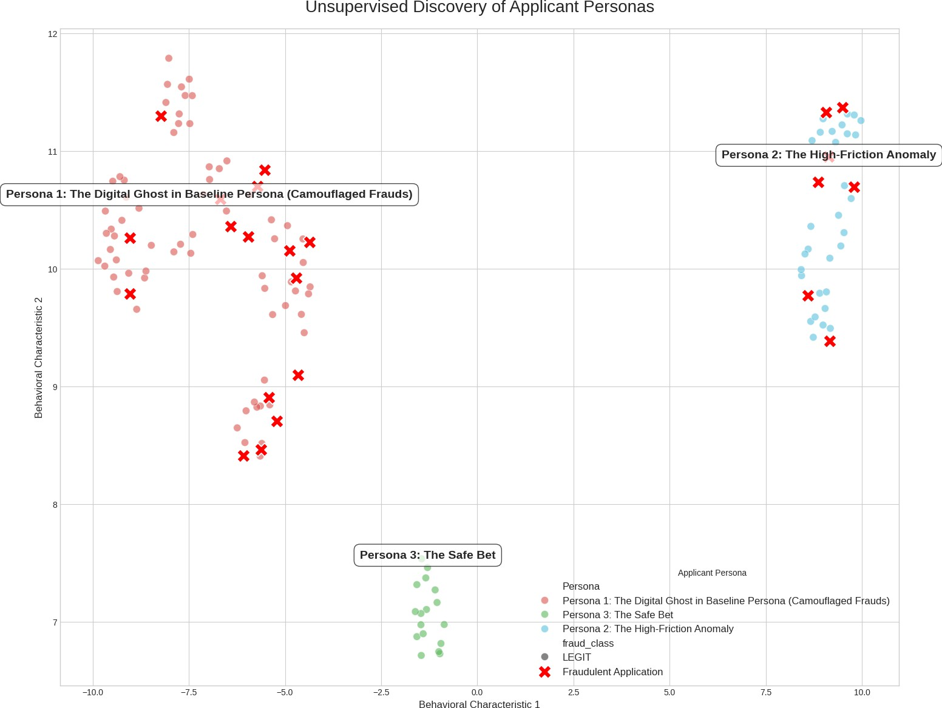

Persona 1: The "Digital Ghost" (High Fraud Concentration)

- What this means: This is your highest-risk group, containing nearly 70% of all fraud cases found in the data.
- The Story: These applicants are deﬁned by a lack of veriﬁable data, triggering 100% fewer identity veriﬁcation checks than the average user. They move through the system without leaving a strong digital footprint, making them inherently high-risk.
- Strategy: These applications should be considered high-priority for review.

Persona 2: The "High-Friction Anomaly"

- What this means: These are applications where the process itself was messy and abnormally slow.
- The Story: This applicant's journey is marked by unusually long pauses—often thousands of percent longer between critical steps. This suggests either careful fabrication of information or signiﬁcant disorganization, presenting a clear operational red ﬂag.
- Strategy: Flag for immediate Enhanced Due Diligence.

Persona 3: The "Safe Bet"

- What this means: This small, distinct group was 100% legitimate in our dataset.
- The Story: This is your ideal returning customer or a new applicant with a very strong, easily veriﬁable proﬁle. They are demonstrably low-risk.
- Strategy: Create a "green lane" for fast-track approvals to improve their customer experience and free up reviewer time.

The Modeling Journey: A Tale of Three Models
Recognizing that no single approach is perfect, we built a state-of-the-art Ensemble Model that combines two different detection philosophies for maximum coverage. Our POC evolved through three distinct modeling phases, each building upon the learnings of the last.

Model 1: The XGBoost "Detective" (The Expert on Known Threats)
- What it is: A powerful, industry-leading supervised learning algorithm (XGBoost).
- How it was built: We trained this model on your 117 labeled applications containing 19 fraud cases.. It learned the complex, subtle patterns that differentiate known FRAUD from known LEGIT cases.
Result 1: The model experienced a generalization failure on the untouched test set, yielding an
AUPRC of 0.1586. This provided a clear, initial diagnosis of data sparsity.
To make it even smarter with limited data, we used a technique called Semi-Supervised Learning, where the previous model also learned the characteristics of your 258 unlabeled applications to get a better sense of a "normal" baseline.
Result 2: The "Detective" model was a major success. The Test Set AUPRC jumped to 0.1785, and more importantly, it achieved a 25% Fraud Recall, successfully identifying 1 of the 4 fraudsters where the previous model saw none. This proved that learning the structure of "normal" from unlabeled data was a highly effective strategy.
- Its Role: The Detective's job is to ﬁnd patterns that look similar to fraud you've seen before. It is an expert on the historical methods of fraudsters.

Model 2: The Isolation Forest "Watchdog" (The Sentry for Never Seen Before New Threats)

- What it is: A highly effective unsupervised anomaly detection algorithm.
- How it was built: The Watchdog was not trained on fraud labels at all. Instead, it studied all 396 real applications to build an incredibly detailed mathematical proﬁle of a "normal" Tower Loan applicant.
- Its Role: Its only job is to sound the alarm when it sees an application that is mathematically "weird" or doesn't ﬁt in—even if it's a type of fraud it has never encountered before. This makes it a crucial safety net against new and emerging fraud tactics.

Model 3 The Final System: The Ensemble "Task Force"
Our ﬁnal model combines the risk scores from both the Detective and the Watchdog. This creates a "Task Force" that is more powerful and robust than either model on its own, balancing deep pattern recognition with broad anomaly detection.
- Methodology: To create a more robust system, we built an ensemble combining two different philosophies:
  - The SSL XGBoost "Detective": Our best supervised model, an expert on known fraud patterns.
  - The Isolation Forest "Watchdog": An unsupervised anomaly detector trained on all 396 real applications to learn a deep proﬁle of "normal" and ﬂag anything mathematically "weird."
- Result: The ﬁnal "Task Force" was evaluated on the test set, with its score being a 50/50 average of the Detective and Watchdog scores.

Final Performance Analysis & The Power of the Ensemble
The ﬁnal evaluation suite tells a clear and powerful story about the trade-offs between different detection strategies. This is a powerful result from a limited one-year dataset and proves that our hybrid approach provides a strong safety net to support your review team.
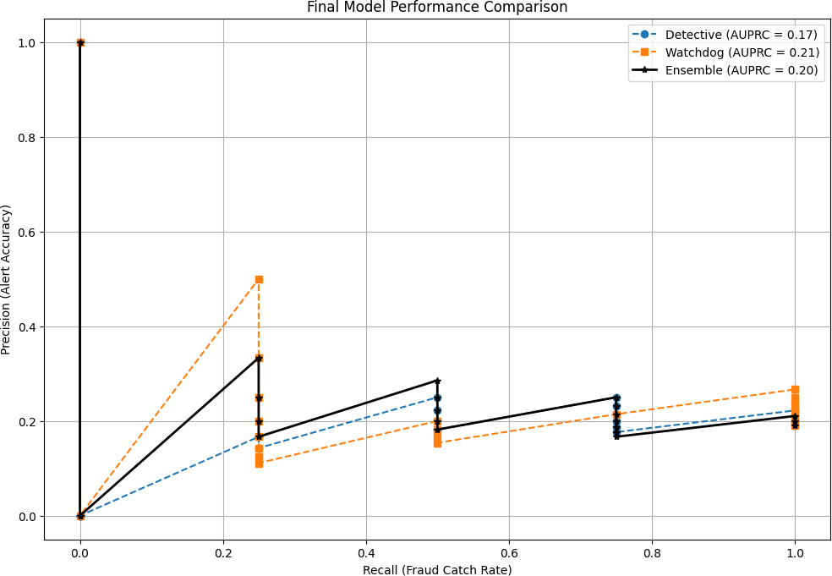

Model Evaluated | Test Set AUPRC | Fraud Recall (Catch Rate) | Fraud Precision (Alert Accuracy) | Key Insight
The Detective (Model 1) | 0.1785 | 25% (1/4) | 14% | A cautious,  evidence-based ranker. Good signal but misses novel anomalies.
The Watchdog | 0.2075 | 100% (4/4) | 21% | A hyper-sensitive alarm. Catches everything but with many false positives.
The Task Force (v5) | 0.1946 | 50% (2/4) | 20% | The optimal compromise. Doubles the Detective's catch rate while ﬁltering the Watchdog's noise.

Final Diagnosis: This POC has proven that the signals for fraud exist within your data. The most direct path to increasing these performance metrics is to train the model on a larger and more diverse set of historical examples.

The Pinnacle of the POC: Building an Intelligent & Transparent Co-Pilot with Fully Explainable AI Reporting
A risk score is useful, but the "why" behind the score is what empowers your team. We built our system with transparency at its core, culminating in a GenAI-powered reporting capability that translates complex model logic into plain English.

Understanding the Model's Overall Brain

First, we validated the model's general logic. This chart shows the top factors the model consistently uses to assess risk across all applications. It has correctly learned that strong identity veriﬁcation (idv_non_null_count) is the most important signal of a legitimate applicant, while behavioral red ﬂags like abnormal application speed (deltaH... features) are strong indicators of risk. This conﬁrms the model's logic is sound.
The discovery of the three applicant personas we discussed in section 3.0 is a powerful tool for strategic triage. However, the most sophisticated fraud—the "camouﬂaged" fraud hiding in the Baseline persona—does not follow simple rules. To catch this, we must understand the speciﬁc "digital ﬁngerprints" our model learned to identify as predictive of risk.
A machine learning model isn't magic; it's a powerful engine that ﬁnds the speciﬁc features that, in

combination, are the most effective at separating known fraudsters from legitimate customers. Our analysis of the ﬁnal, trained model revealed several key categories of predictors. This conﬁrms that our model is not a "black box" but is making intelligent decisions based on sound business logic.

Category 1: Behavioral & Timing Anomalies (How They Apply)

This was our most powerful discovery. The process of an application is as predictive as the data within it.

- Key Predictors: deltaH (features measuring time gaps in the application)
- Business Insight: Our model learned that applications with unusually long pauses (e.g., several hours) between completing the personal information section and the employment section are signiﬁcantly higher risk.
- The Story This Tells: A legitimate applicant typically proceeds smoothly. A fraudster, however, may be taking time to look up or fabricate false employment details, social security numbers, or addresses. Our model has successfully quantiﬁed this "hesitation" as a major risk signal, something a simple rule cannot easily capture.

Category 2: Contact Information Footprint (Synthetic vs. Real Identities)

Fraudsters often create synthetic or "burner" identities, and this leaves a clear footprint in their contact data.

- Key Predictors: email_local_len (Length of the email before the "@"), email_local_digit_ratio (Percentage of numbers in the email)
- Business Insight: The model learned that legitimate customers tend to have established, simpler email addresses. In contrast, it ﬂags applications with abnormally long emails or emails packed with a high ratio of numbers (e.g., johnsmith81375924@... vs. jsmith82@ ).
- The Story This Tells: This pattern is a classic indicator of an auto-generated or "burner" email account created speciﬁcally for this application, rather than a person's real, primary email.
Category 3: Proﬁle & Stability Factors

Finally, the model validated core, intuitive underwriting logic, but with a data-driven precision.

- Key Predictors: ...age_rulesengine...bucket_, ...monthsemployed bucket_
- Business Insight: Our model conﬁrmed that certain combinations, such as a very young applicant (e.g., 21-31 age bucket) paired with a very short employment history, represent a statistically higher risk proﬁle in your data.
- The Story This Tells: This is the most important part: the model doesn't just treat these as simple rules. It uses them as weights in a complex calculation. It can learn, for example, that a "young applicant with low employment time" is low-risk IF all their behavioral signals are perfect, but is extremely high-risk IF they also have a high email digit ratio and long application pauses.

Category 4: Application Effort & Identity Struggle (Signs of Friction)

Legitimate applicants usually provide their information cleanly. Our model learned that applications that "struggle" against your automated systems are highly suspicious.
- Key Predictor: idv_non_null_count (Identity Veriﬁcation Check Count)
- Business Insight: This directly supports the value of your existing systems. Our model conﬁrmed that a high number of IDV checks is a powerful predictor of fraud. We found the high-risk "Anomaly"

persona had 200% more IDV checks than the average.
- The Story This Tells: The model isn't just ﬂagging this one factor. It has learned that an applicant who has both a high IDV count and a long application pause is an exponentially higher risk than an applicant who only has one. This interaction effect is the key.

How to Read This Chart: Each feature is ranked by importance. For each one, the red dots represent applicants with a high value for that feature, while blue dots represent a low value. Dots pushed to the right increase the fraud score; dots to the left decrease it.
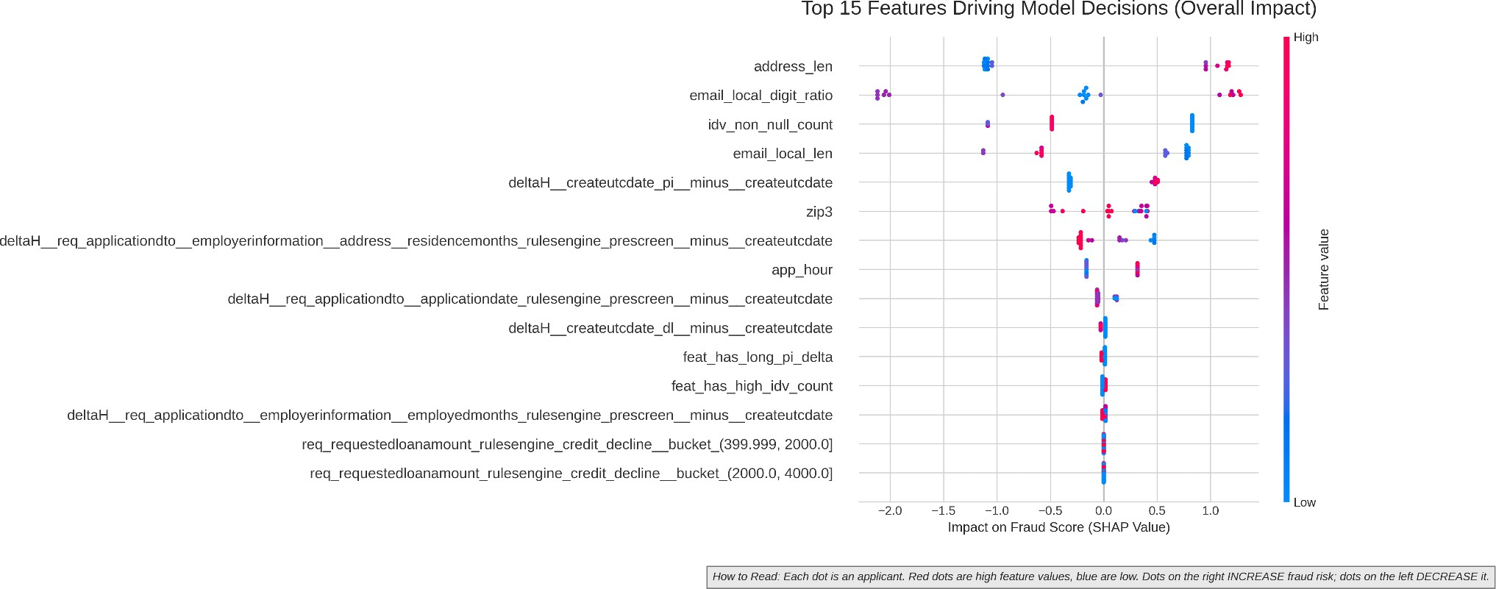

The "Why" Behind a Single Prediction

This transparency extends to every single applicant. The model acts as a co-pilot for your team by providing a simple summary of the reasons for its risk assessment. This "waterfall" plot shows exactly how the ﬁnal risk score was calculated, starting from a baseline and showing how each key feature pushed the score up (in red) or down (in blue).
This level of detail allows your team to trust the model's output and immediately focus their investigation on the speciﬁc data points that the system found suspicious.

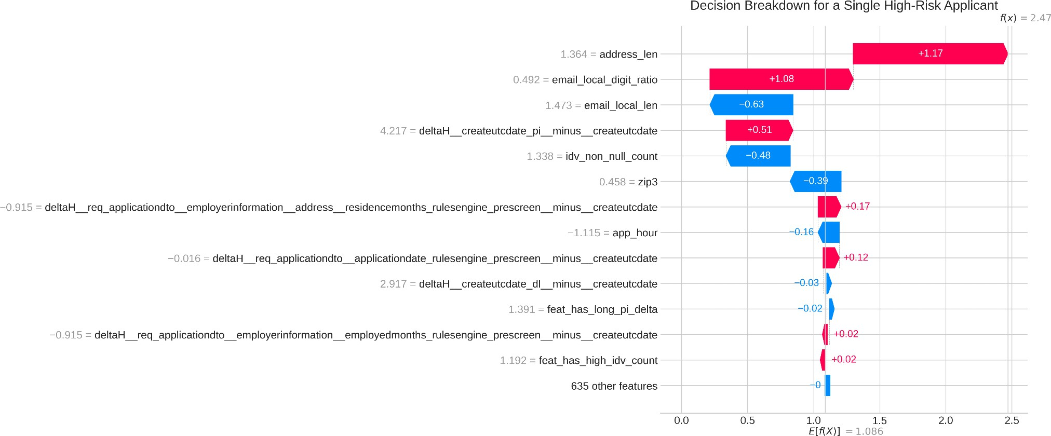

The Final Deliverable: The GenAI-Powered Fraud Report

While the charts above are powerful, we recognized the need to make these insights instantly accessible without requiring technical interpretation. As the ﬁnal step in this POC, we integrated a Generative AI (GenAI) layer.
This system takes the model's score and the complex SHAP explanation data and automatically generates a concise, human-readable PDF report. For every application ﬂagged for review, your team will receive a summary that answers key questions for example:
- What is the risk? (e.g., "This application has a 64.13% probability of being fraudulent.")
- Why is it risky? (e.g., "The primary risk factors are an unusually high number of digits in the email address and an application completion time that is signiﬁcantly faster than normal, suggesting automated activity.")
- Are there mitigating factors? (e.g., "However, the applicant's VantageScore falls within a normal range and their stated monthly income is consistent with their proﬁle, which lowers the overall risk from being higher.")

This GenAI-powered report is the ultimate deliverable of the co-pilot system, turning raw data into actionable intelligence and opening the window into why the model makes its decisions.

Strategic Recommendations & Our Partnership
This POC has laid a clear and conﬁdent path forward to enhance your team's capabilities and secure your application process.
Primary Objective: Data Acquisition. The conclusive ﬁnding of this POC is that the single most impactful action to improve both Recall and Precision is to increase the number of labeled fraud or legitimate examples from the last 2-3 years of operations.
Future Work: Re-run the Existing Pipeline. The complete, multi-stage pipeline we have built is a valuable asset. It is production-ready and can be re-run on a larger dataset to train a new, even more powerful generation of models.

Phase 1: Deploy the Intelligent Co-Pilot
- Action: We will partner with your team to deploy the Ensemble Model as a live decision-support tool. As applications arrive in the TLOS LoanApplication table, the model will automatically generate a risk score and an explanation report for your review team.

- Beneﬁt: This approach augments your team's expertise. It provides them with immediate, data-driven insights, allowing them to more quickly and conﬁdently identify both subtle and obvious risks, making the review process smoother, more robust, and more accurate from day one.
Phase 2 : Building the High-Precision Automated Solution
- Action: The next strategic step is a joint initiative to expand the dataset of labeled fraud examples from the last 2-3 years of operations.

- Beneﬁt: With this richer dataset, our existing pipeline is poised to deliver a model with the high precision and conﬁdence most importantly required to ﬂag risk applications but also to begin automating approvals for the clearest low-risk cases. This will lead to signiﬁcant reductions in fraud losses, decrease the long-term burden on manual reviewers, and create a lasting, scalable strategic advantage for Tower Loan.

Operational Flow of the Fraud Detector (Future-State)
This section outlines the end-to-end technical process for integrating the Fraud Detection Co-Pilot seamlessly into the Tower Loan application lifecycle.

System Process Overview

The proposed fraud detection pipeline will slot seamlessly into the existing OLL → TLOS loan lifecycle. The high-level process is as follows:
- New ApplicationIntake (OLL): An applicant submits their data through the Online Lending system. Data is stored in OLL tables such as IdentityVeriﬁcation, PersonalInformation, ApplicantDriversLicense, ApplicantAddress, FinancialInformation, EmployerInformation, LoanApplication_branch_ﬁltered_v2 etc.
- Pre-Funding Stage (TLOS): The application passes initial underwriting and lands in the TLOS LoanApplication table. This is the trigger point for our fraud detection system.
- Fraud Detection System Data Enrichment & Feature Engineering: The application record is fed into our production-ready preprocessing pipeline. Approximately 100 raw data points are expanded into over 650 predictive features, capturing applicant behavior, Fraud-sensitive derived features (e.g., delta times, idv counts, address patterns) are generated, and time-based patterns.
- Ensemble Model Scoring: The "Task Force" model (SSL Detective + Watchdog) analyzes the feature set and assigns a single FraudProbabilityScore (from 0.0 to 1.0).
- Output to TLOS: The system writes two new ﬁelds back to the LoanApplication table:
  - FraudScore (the numeric probability).
  - FraudFlag (a binary 1 for 'Review Recommended' or 0 for 'Nominal Risk').
- Explainable AI Reporting: Simultaneously, the model's reasoning is captured and a plain-English explanation is logged (e.g., "Flagged due to high-velocity application completion time and low count of

veriﬁed identity documents.").
- Review Queue Triage: Flagged applications are routed to the appropriate reviewer queue based on established risk thresholds, allowing the team to prioritize the most suspicious cases.
- Continuous Improvement Loop: As loans mature and outcomes are recorded in TLOS (e.g.,
ﬁrst-payment default, early reversal), these "ground truth" labels are automatically captured. This data is used in periodic retraining cycles to ensure the model continuously adapts and improves its accuracy over time.

System Architecture Blueprint

This diagram illustrates the ﬂow of data from initial application to the continuous model improvement feedback loop.
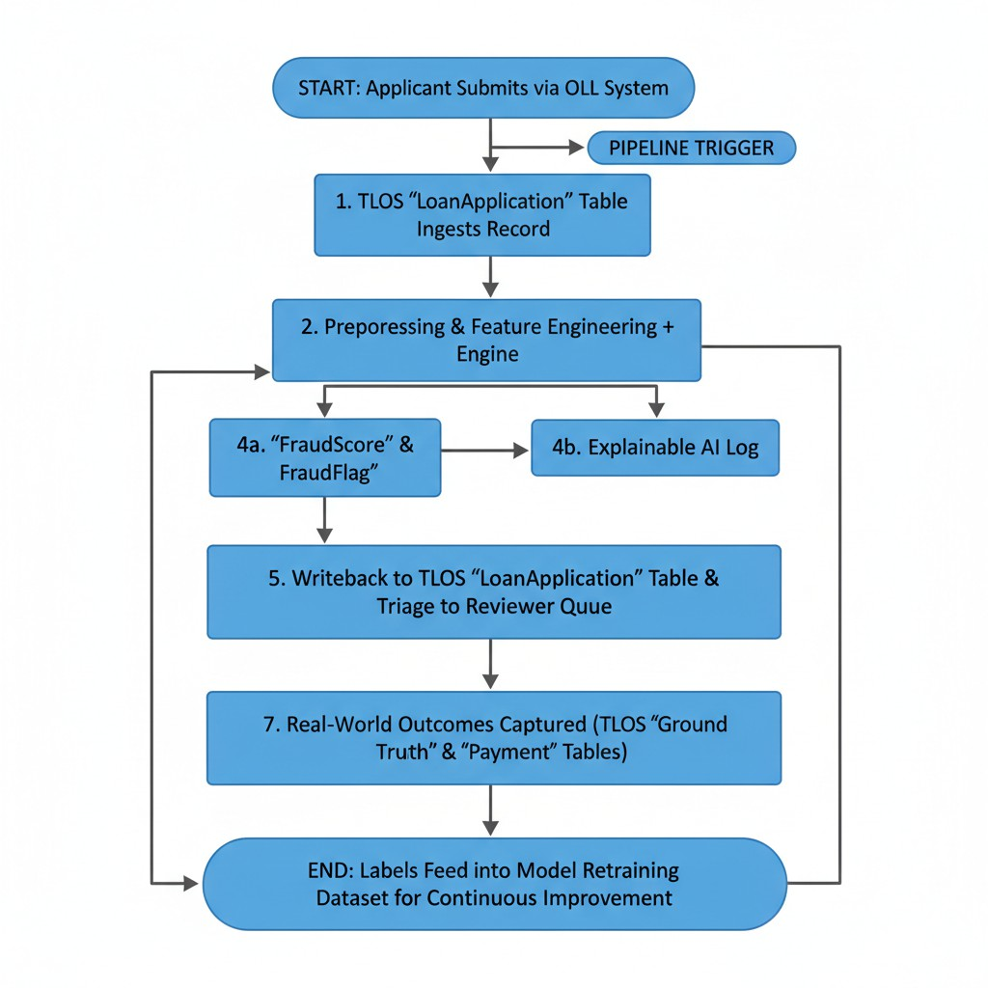

Message to the Development Team

Team,

As we move to productionalize the Fraud Detection POC, here is the core integration logic. Our goal is to hook directly into the existing TLOS workﬂow.
    - Trigger Point: Our service will listen for new record insertions into the TLOS LoanApplication table.
    - Processing: Upon trigger, we will execute the feature engineering pipeline and score the record using the deployed Ensemble model.
    - Outputs: The service's primary outputs are two new ﬁelds to be added to the LoanApplication table: FraudScore (ﬂoat) and FraudFlag (boolean/integer). An associated explainability log report will be written for all ﬂagged applications.
    - Review Flow: Flagged applications (e.g., FraudFlag = 1) should be routed to a dedicated review queue in the team's dashboard, sorted by FraudScore descending.
    - Feedback Loop: We will need a separate process to ETL loan outcomes (defaults, reversals, etc.) from the Loan and Payment tables to create a ground-truth labeling system for future model retraining.
This creates a closed-loop system where we not only predict risk but also learn from every loan cycle to get progressively smarter.

Conclusion & Next Steps
This 6-week Proof of Concept (POC) has been successfully completed. Together with Tower Loan, we transformed raw data into a cohesive intelligence asset, constructed an ensemble fraud detection system, and demonstrated its ability to identify previously unseen fraud cases with explainable, data-driven insights.
The POC has validated that Tower Loan’s data holds powerful fraud signals and that a hybrid approach combining supervised and unsupervised learning with Generative AI explainability can serve as an intelligent co-pilot for the review team. The discovery of applicant personas, the creation of a ground-truth dataset, and the deployment of transparent, explainable risk scoring represent a strong foundation for a scalable fraud detection program.

